Culminating Task
[Name]
[Institution affiliation]
[Course]
[Date]

Step 1: An Environmental Issue
Using plastic garbage is among the most environmental pollution issues in the current world since the plastic’s decomposition takes millions of years. Therefore, there is a rapid increase in environmental pollution with such a global error whereby people are using more plastic on a daily basis. As a result, this not only risks both the current and future human lives, but it also exposes our wildlife and oceans in danger. However, my proposal entails tightening and strengthening the “reduce, recycle, and reduce” campaign that will be assisting in lessening or minimizing the global use of plastics. Besides, the campaign is guided by the fact that we can all participate in enlightening other individuals into using recyclable items towards reducing the produced waste, and the reuse such items to assist in minimizing waste or pollution across our environment.
Step 2: Secondary Data Research
Below is the data I had managed to retrieve online as I was conducting a detailed research and the links are provided. Ourworldindata.org shows that plastic worth 7.8 million tons had already been produced, and this is equivalent to one ton of plastic as per each individual currently alive. Therefore, the chart below presents the global production of plastics from 1950 to 2015, or the yearly global production of fiber and resin in metric tons. As it is seen from graph 1 below, there is a production increase at a higher level. For instance, the global plastic production in 1950 was just 2 million tons annually. Since then, however, there an increase in the yearly plastic production by almost 200-times, leading to 381 million tone in the year 2015, something which was almost equal to two-thirds of the global population.
Graph 1
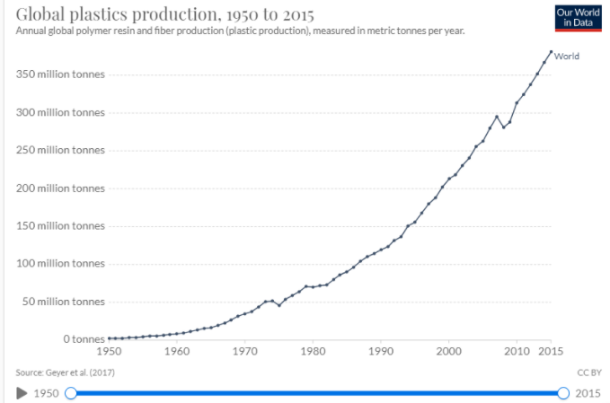
On the other hand, however, graph 2 presents the global cumulative production of plastics from 1950 to 2015 in tons. As one can see, the production’s upward trend implies that plastics will be used more across the world.
Graph 2
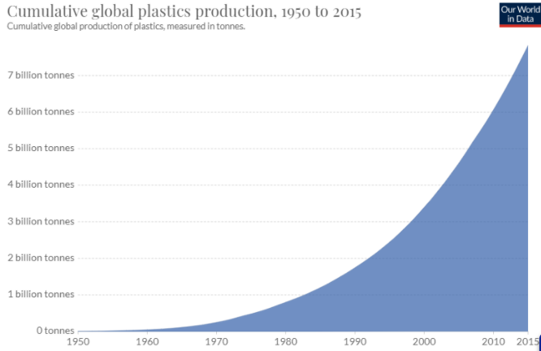
Step 3: Graphic Representations
The sample data provides the accumulated displaced plastic waste resulting from the import ban in China as it is shown in the linear graph below. We can see that there will be a substantial increase if by any chance the world is going to displace plastic ranging from a scale of 50%, 75%, and 100%.
Graph 3
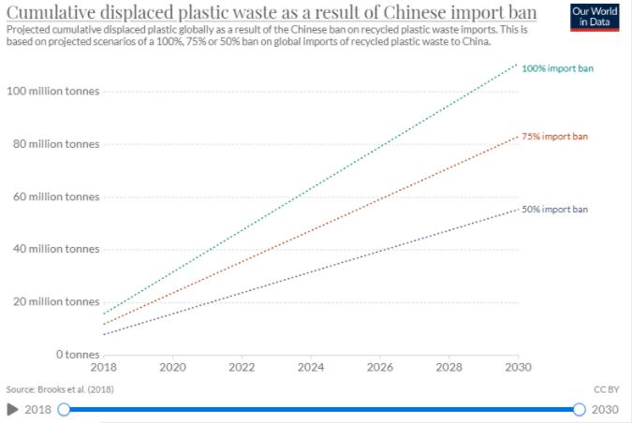
With such information on mind, we believe that we can make the world the best place to live in with our “reduce, recycle, and reuse” campaign if we join efforts together in eradicating plastic pollution. By doing so, we will all be saving the future generations by having greener pastures.
Online research link
https://ourworldindata.org/plastic-pollution

